**BUSINESS REPORT ABOUT OPERATION AND SUPPLY CHAIN PERFORMANCE ISSUES OF A COMPANY**

Contents

**1.** **Introduction** 3

**2.** **Analysis of the company’s current performance** 3

*2.1.* *Overall product family* 3

*Figure 1: Sales by Product Family* 4

*Figure 2: Average Due Date Performance by each Product Family* 5

*Figure 3: Price distribution by Product Family* 6

*2.2.* *Bins* 6

*Figure 4: Total sales of Bins between 2006 and 2012.* 7

*Figure 5: Total sales of Bins product between 2006 and 2012.* 8

*2.3.* *Self-watering planters* 8

*Figure 6: Sales by colours of Self-watering products* 9

*Figure 7: Colour used by powder weight for self-watering planters.* 10

*Figure 8: Total sales for Self-watering planters between 2006 and 2012.* 10

*Figure 9: Total sales of self-watering planters between 2006 and 2012.* 11

*2.4.* *Planterware* 11

*Figure 10: Total sales of planterware from 2010 to 2012.* 12

*Figure 11: Total sales performance of planterware during from 2010 to 2012.* 12

*2.5.* *Supply chain and operation model* 13

*Figure 12: Fisher’s framework, Matching supply chains with products (Fisher, 1997)* 14

**3.** **Predictions of Sales and Demand** 16

*Figure 13: Sales forecast of Planterware products* 16

*Figure 14: Sales forecast of Self-watering products with special colours* 17

*Figure 15: Typical demand distribution for product family.* 18

*Figure 16: 3-year forecast for the demand of each product family.* 19

**4.** **Recommendations** 20

*4.1.* *Coordinated strategies.* 20

*Figure 17: Coordinated Strategies.* 22

*4.2.* *Realigning the supply chain* 23

4.3. Economic Order Quantity model 24

**References** 25

**Appendices** 28

Appendix 1: Data Types 28

Appendix 2: Descriptive statistics of Due Date Performance 28

# **Introduction**

This report will provide a comprehensive analysis of the sales performance as well as operation and supply chain management by the data provided from a gardening product company. Moreover, the study will begin with an overview of the gardening products industry by utilising descriptive analytics and data mining techniques to identify patterns and relationships between the company's sales performance and factors such as price, size, and colour, then applying predictive analytics to predict the trends driving its growth, as well as an introduction to the company and its product range. Additionally, the Fisher model will be applied to assess the company's supply chain characteristics and determine whether they align with the company's product lines. Finally, the report will provide strategic recommendations from supply chain management and operations strategy to assist the company in managerial decision-making, while improving the company’s overall performance and addressing potential challenges that may arise in the future.

# **An Analysis of the company’s current performance**

* 1. *Overall product family*

Prior to the launch of planterware, sales of bins and self-watering planters generated an average revenue of approximately £1.48 million, with the latter accounting for 86.9% of total sales during the period between 2006 and 2009, (Figure 1). Since the introduction of the company's new product line, Planterware, in 2010, accompanied by a diverse range of colour offerings to customers, a noteworthy improvement in total sales performance has been observed, resulting in a figure exceeding £2.3 million in 2012.

### *Figure 1: Sales by Product Family*

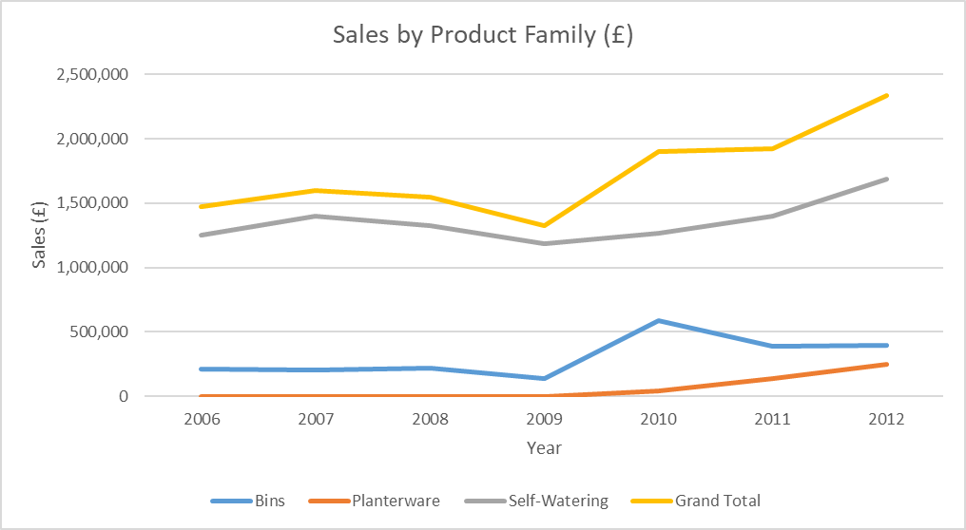

According to the findings presented in Figure 2, the Self-Watering product family outperformed the other two product families in terms of due date performance (DDP), with an average DDP of 95.23%. Conversely, the Planterware product family demonstrated a slightly lower average DDP of 95.03%, while the Bins product family displayed the least impressive average DDP at 94.15%.

### *Figure 2: Average Due Date Performance by each Product Family*

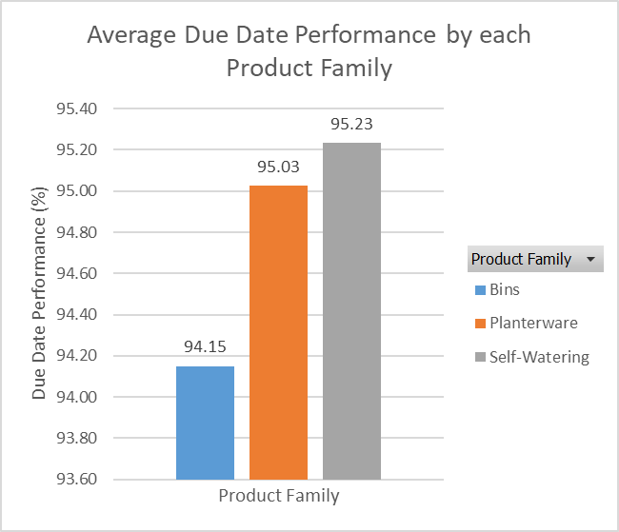

In terms of price, Figure 3 presents that the Bins product family had the highest average price of £197, ranging from £50 to £450. The Self-Watering product family had a slightly lower average price of £194, with the price range spanning from £25 (the cheapest) to £700 (the most expensive). Meanwhile, the Planterware product family had the lowest average price of £57, with its price range ranging from £30 (the cheapest) to £90 (the most expensive) (see Figure 3 for further information).

### *Figure 3: Price distribution by Product Family*

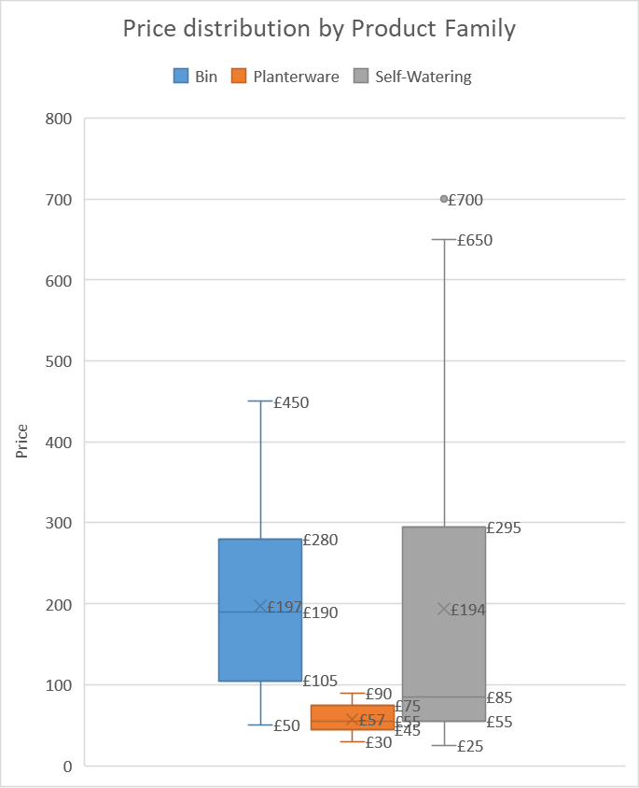

* 1. *Bins*

Among the three product families, the range of bins offered by the company is the least diverse, comprising only 20 different types that are exclusively available in black colour. Over a period of seven years, the sales generated by the bin products amounted to only slightly over £2.1 million, representing less than one-fifth, or 17.8%, of the company's total sales performance. Figure 2 demonstrates that West min bin, Olympic dual bin, and West min liner are the top-selling products in the bins product category.

### *Figure 4: Total sales of Bins between 2006 and 2012.*

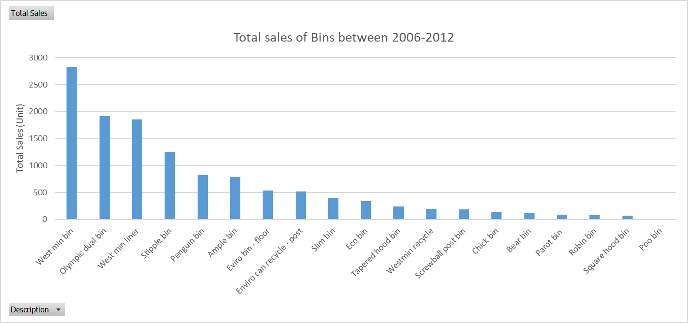

According to Figure 3, it is evident that despite being introduced in 2009, the OLY 1P, an Olympic dual bin, is the most profitable product. In particular, the bins product witnessed a considerable boost in its sales with the introduction of the Olympic dual bin, which accounted for 954 units sold in 2010, generating a total revenue of over £860 thousand. As a result, this product's success contributed to approximately 40% of the overall sales of the bins product throughout the period.

### *Figure 5: Total sales of Bins product between 2006 and 2012.*

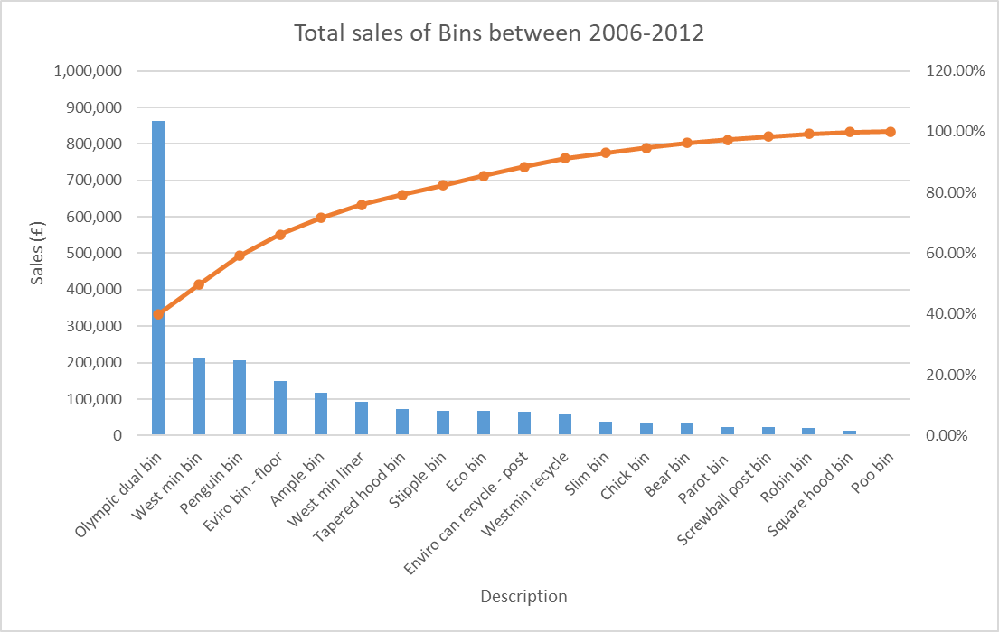

* 1. *Self-watering planters*

The company's sales are contributed by its 29 different self-watering planters, which come in a range of colours and design choices. During the 2011-2012 period, the sales performance of the self-watering planters product family was sustained by the company's introduction of various special colours to its product line. Before this time, the products were limited to black and standard green, also referred to as standard colours. Figure 4 demonstrates that in the period spanning from 2006 to 2012, standard colour product sales averaged £1.2 million annually, remaining largely consistent. However, a peak in total sales, reaching approximately £1.7 million, was observed in 2012, when the company introduced special colour products to the market.

### *Figure 6: Sales by colours of Self-watering products*

In detail, the demand for black products used to be the highest between 2018 and 2011, with the average of 107kg of its powder weight, before being overtaken by the standard green products. Over the last two years, there has been a notable increase in the demand for special colours, including pink granite, guernsey granite, and brown, with approximately 32 thousand kg, 19 thousand kg, and 15 thousand kg of powder weight requested, respectively (Figure 5).

### *Figure 7: Colour used by powder weight for self-watering planters.*

Furthermore, the product lines of Half basket up the pole, Cup and Saucer, and Cup and Saucer on pole have emerged as the highest-selling self-watering planters, representing approximately 40% of the total sales of this product category during the period shown in Figure 6 and 7.

### *Figure 8: Total sales for Self-watering planters between 2006 and 2012.*

### *Figure 9: Total sales of self-watering planters between 2006 and 2012.*

* 1. *Planterware*

The Planterware product family, introduced in 2010, had a noteworthy impact on the company's sales performance from 2010 to 2012, with a total revenue exceeding £430 thousand. The family consisted of ten distinctive products, with the Plain vase, Rectangular container, as well as Egg pot vase being the most favourable and responsible for 66% of family's total sales (refer to Figure 11 for details). To cater to customers' varied preferences, the newly launched product line was offered in diverse designs and sizes.

### *Figure 10: Total sales of planterware from 2010 to 2012.*

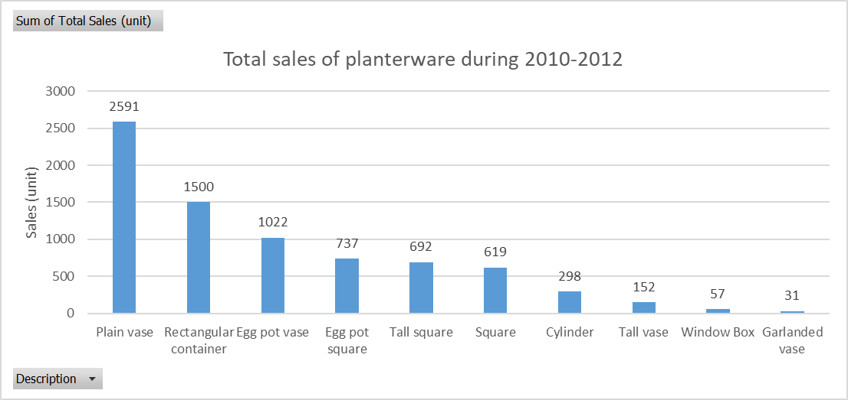

### *Figure 11: Total sales performance of planterware during from 2010 to 2012.*

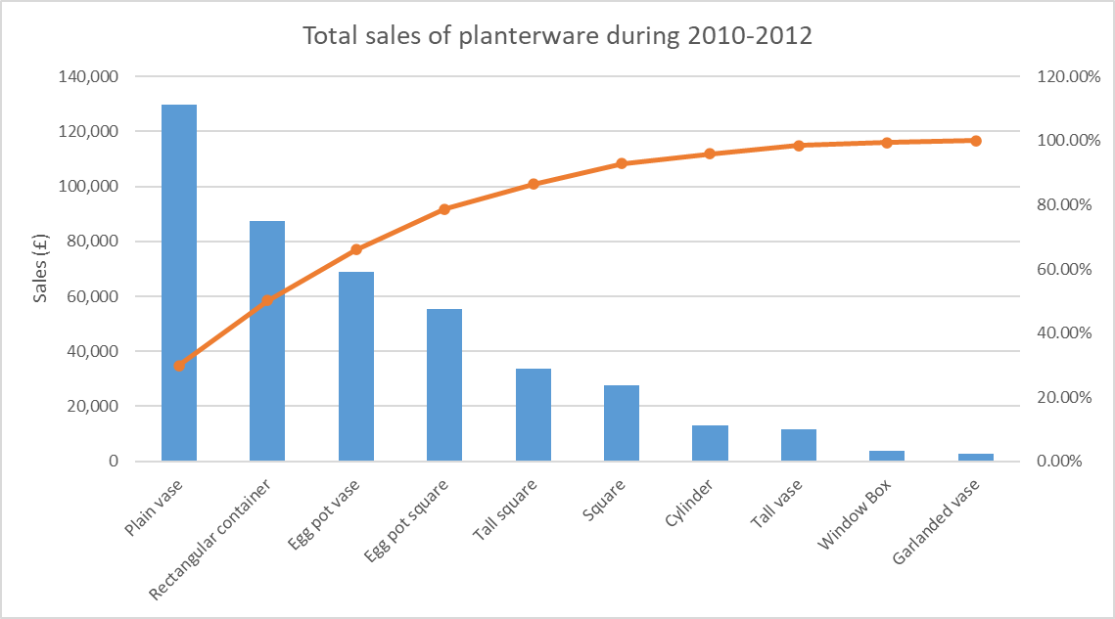

Based on the descriptive statistics from Appendix 1 of due date performance, it can be confirmed that the company is failing to meet promised delivery times, which is contrary to what is stated in the literature. It can be clearly seen that the average due date performance is 95%, which means that the average customer is not receiving their product on time. However, the service level has not fallen below 90%, and the performance dates are quite stable, indicating a fairly symmetrical and light-tailed distribution. These findings suggest that the company has not been able to manage unexpected situations leading to delays, while the production process is limited in capacity, resulting in delayed deliveries. It should be noted that demand is not the limiting factor, but rather the production line's capacity, which acts as a bottleneck, thereby limiting production. Despite the possibility of increasing production, the capacity constraint restricts further throughput maximization. In line with Goldratt's Theory of Constraints, the company's constraint is capacity, which hampers business performance (Goldratt, 1984).

* 1. *Supply chain and operation model*

According to Fisher (1997), supply chain is divided into two different types: physically efficient and market responsive. Cost savings and optimal utilisation of resources are the main goals of a physically efficient supply chain. By eradicating all non-value-added tasks, following economies of scale, and optimising the consumption of resources, the physically efficient supply chain seeks to attain the lowest cost of operation (Harris and Componation, 2005). However, because it aims to improve supply chain cost efficiencies while being less flexible (Lee, 2002), its capacity to quickly adapt to market changes may be constrained (Randall et al.,2003).

Companies that adopt a market responsive supply chain strategy prioritise meeting customer delivery requirements, regardless of demand variability. Flexibility and order accuracy are essential elements of this approach (Lee, 2002; Maltz and Maltz, 1998). Such companies use strategically placed inventories to avoid the risks of supply disruptions and adapt to customer, market, and supply uncertainty (Harris and Componation, 2005). A market responsive strategy encourages build-to-order and mass customization processes to meet customer expectations. However, there is a higher potential for stock-outs when product demand is uncertain and variable, which can lead to substantial profit loss for products with high profit margins. In such cases, companies redirect their focus towards increasing speed and flexibility by executing a market responsive strategy (Fisher, 1997; Randall et al., 2003; David et al., 2002). Fisher (1997) suggests that every dollar invested in improving the supply chain's responsiveness to an innovative product led to savings of more than a dollar in reduced costs of stock-outs and forced markdowns. A market responsive supply chain network emphasises order cycle time, even at the expense of efficiency.

### *Figure 12: Fisher’s framework, Matching supply chains with products (Fisher, 1997)*

According to Fisher's (1997) model, a lean supply chain approach focuses on reducing supply chain costs by efficiently managing inventory and enhancing supply chain quality, thereby eliminating waste (Huang et al., 2002; Christopher and Towill, 2000). Lean supply chain advocates may adopt a just-in-time strategy, which aims to deliver the correct amount of materials at the right time and place and may choose suppliers based on quality to achieve cost savings (Borgstrom and Hertz, 2011; Qi et al., 2009). On the other hand, an agile supply chain strategy aims to be flexible by adapting rapidly and effectively to ever-changing customer demands (Huang et al., 2002; Christopher and Towill, 2000; Lin et al., 2006). In order to offer supply chains with the ability to deliver customised goods to clients, an agile approach implements a "wait-and-see" method to demand, avoiding product commitments until demand becomes transparent (Goldsby et al., 2006). Moreover, for the purpose of enhancing the responsiveness of the supply chain in a constantly changing market, an agile approach requires a larger capacity buffer to be maintained, as suggested by Qi et al. (2009).

Fisher (1997) emphasises the importance of aligning the supply chain structure with product demand dynamics. The incorporation of principles of uncertainty, trade-offs, and buffering mechanisms such as inventory, capacity, and time is essential. This model suggests that an efficient supply chain is suitable for functional products with low customer demand variability, while responsive supply chains are better suited for innovative products with high demand uncertainty. Functional products are characterised by stable and predictable demand and are considered staple items that meet basic customer needs, whereas innovative products are unique and designed to meet special customer needs, making demand unpredictable and difficult to forecast. Cost-wise, functional products are associated with physical costs such as production, transportation, and inventory, while innovative products have market mediation costs caused by missed sales opportunities and dissatisfied customers (Fisher, 1997). When supply exceeds demand, the company may need to implement sales at a discounted price to clear inventory. Conversely, when demand exceeds supply, the company loses customers to its competitors (Fisher, 1997).

In this case, the selection of the product colour is made by the customers at the time of placing their order, which restricts the use of Assemble-to-Order (ATO) or Leagile supply approaches (Olhager, 2003; Mason-Jones et al., 2000). The company's operations are based on a Make-to-Order (MTO) environment, which increases the difficulty of managing demand uncertainty. To ensure operational stability, the company may require an escalation function for buffer management to identify when the system begins to exhibit chaos (Olhager, 2003). In addition, Make-To-Order (MTO) business model in terms of supply chain which offers several benefits such as reduced inventory costs, increased flexibility, and improved customer satisfaction (Vonderembse et al., 2006; Grawe et al., 2013). In this model, products are manufactured only when customer orders are received, which eliminates the need for maintaining large inventory levels. This reduces the holding costs and associated risks of inventory obsolescence or spoilage. Additionally, the MTO model allows for greater flexibility in responding to customer demands by producing customised products according to their specific requirements. This leads to improved customer satisfaction and loyalty, which is a critical factor for long-term success in the market (Grawe et al., 2013).

# **Predictions of Sales and Demand**

As per the findings of the exponential smoothing approach, there is a considerable anticipated increase in the sales of planterware and special coloured self-watering planters in the upcoming year. It is projected that the sales of planterware could exceed £351 thousand in 2013 and even more than £556 thousand in 2015, whereas the sales of special coloured self-watering planters are anticipated to surpass £559 thousand in 2013.

### *Figure 13: Sales forecast of Planterware products*

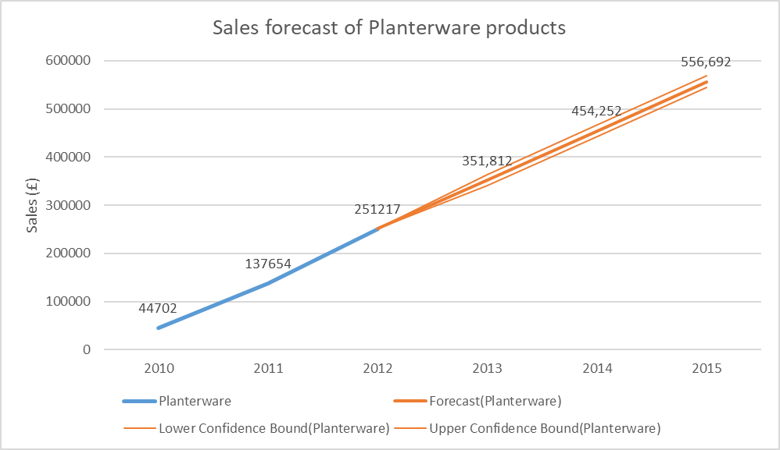

### *Figure 14: Sales forecast of Self-watering products with special colours*

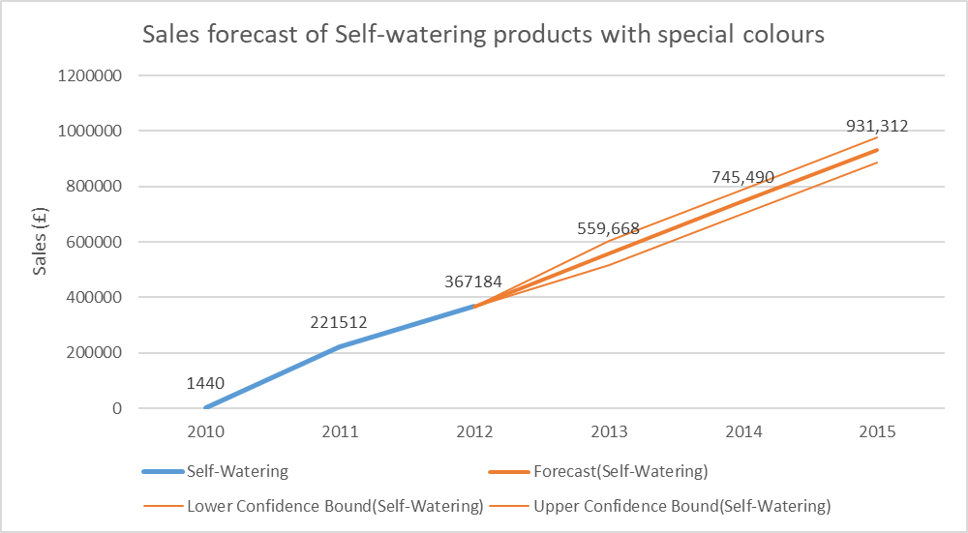

The surge in demand for innovative products is likely to improve the efficiency of the company's production process and increase their revenue. However, this surge in demand also poses a significant threat to the company's supply chain management. The increase in demand may put a strain on the capacity resources of the supply chain, especially since the company operates on a make-to-order (MTO) business model. In such a model, there is a risk of obsolescence and excess supplier costs, which require capacity buffering to mitigate. This, in turn, can impact the overall supply chain performance, and lead to delays in delivering products to customers, which could cause customer dissatisfaction and loss of business. Thus, the company needs to be proactive in anticipating the increased demand and plan accordingly to ensure that their supply chain is capable of meeting the demand while maintaining operational stability. This may involve implementing capacity buffering strategies and investing in new production technologies to increase their production capacity and streamline their supply chain processes.

### *Figure 15: Typical demand distribution for product family.*

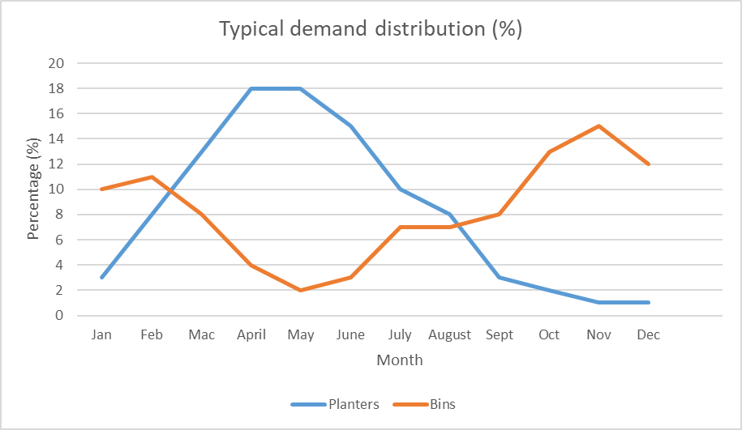

Furthermore, the demand for planters is seasonal, meaning that sales are heavily reliant on the time of year. Hence, the demand for planter products, which are primarily sold during Spring, puts significant pressure on the company's capacity during that period. The distribution of demand for planter and bin products throughout the year can be observed in Figure 14, which shows a clear seasonal pattern for planters. Specifically, planter sales surge during Spring (January to March) and remain steady throughout the Summer, before tapering off during Autumn and Winter. From February to August, the demand for planter products constitutes a significant proportion of the company's annual sales, with the peak demand period occurring in April and May, accounting for 36% of total yearly sales. In contrast, demand for bins follows an opposite trend to planters, which enables the company to handle both product families simultaneously. Nonetheless, bins are not seasonal products, and their demand may not be predictable in the future, posing a challenge to the company's capacity planning if the high demand for bins overlaps with the peak season of planters. The company's capacity constraint is also reflected in the product's due date performance, which currently stands at 95%, indicating that the company fulfils only 95% of customer orders by the promised due date. As a result, customers may seek other suppliers to fulfil their needs, increasing mediation costs as the company loses customers to competitors. Ultimately, the sustainability of the company's sales performance in the future is uncertain due to the possibility of competitors replicating its innovative products, which would diminish the company's competitive advantage based on its make-to-order (MTO) business model..

Utilizing a yearly total sales trend instead of a seasonal trend can display a more apparent pattern in demand prediction, as the seasonal ratio data remains constant. Figure 16 illustrates the predictions, indicating the potential for demand to either increase or decrease.

### *Figure 16: 3-year forecast for the demand of each product family.*

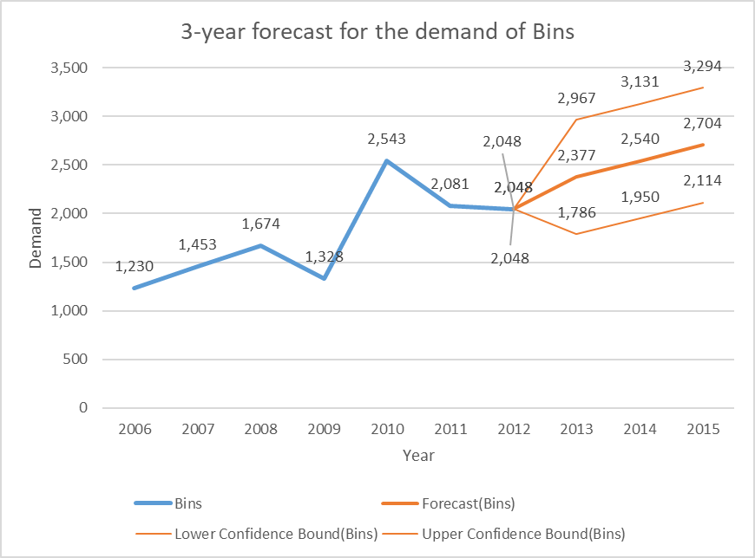

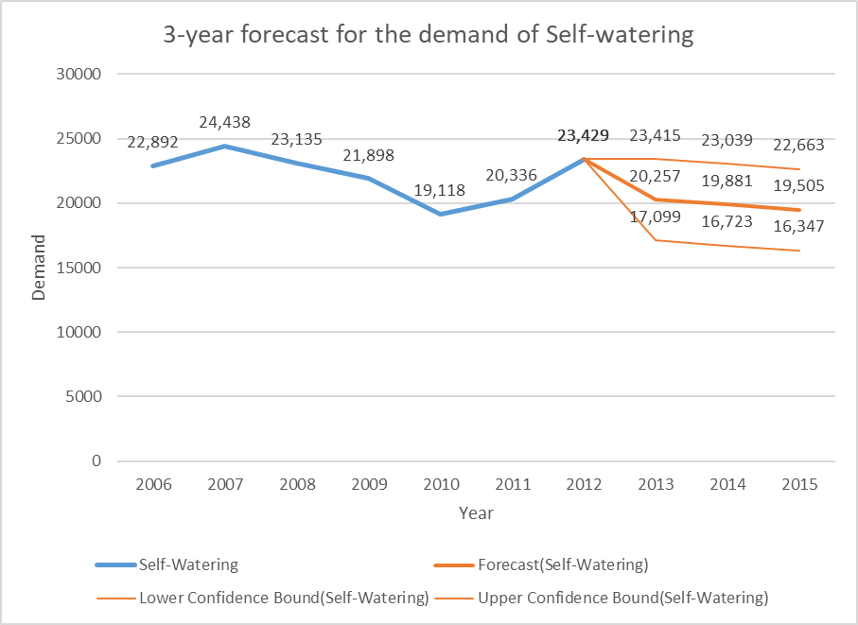

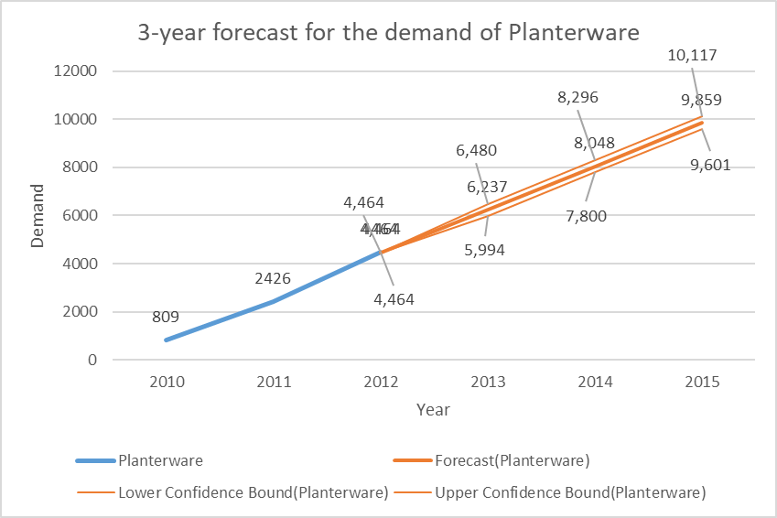

# **Recommendations**

* 1. *Coordinated strategies.*

According to the analysis results that reveal capacity constraints, forecasts indicating demand growth, and discussions on the possible consequences of misalignment, the current strategy of the company needs to be revised to avoid negative implications. As the company introduces new colours and product ranges, it is expected that the sales demand will continue to grow across all product families. Hence, it may be advantageous for the company to implement a strategy that separates functional and innovative products, enabling them to manage capacity constraints effectively. This can be accomplished by piloting an efficient supply chain strategy on a specific product and gradually expanding it to other products if successful. By doing so, the company can gain a better understanding of how to manage demand uncertainty and reduce the risk of obsolescence and excess supplier costs. Such an approach would also help the company maintain a competitive edge as it navigates through an increasingly dynamic market. According to Fisher (1997), coordinated strategies can help balance inventory and service level costs, leading to optimal supply chain performance. MTO strategy can be implemented to reduce inventory levels and eliminate the need for unnecessary capacity by producing goods only when there is demand. However, make-to-order (MTO) production strategy is suitable for products with a predictable level of demand (Zhang and Zhang, 2010). Therefore, by implementing MTA, companies can achieve better control over inventory levels and minimise the risk of overproduction, while also improving delivery times through frequent replenishment (Mellat-Parast and Spillan, 2014).

Make-to-assemble (MTA) is a manufacturing strategy that focuses on producing components and subassemblies based on actual customer orders and assembling them into final products only when demand is identified. In addition to reducing inventory levels and minimising the risk of overproduction, the MTA strategy also offers other benefits in aligning products with the supply chain. For instance, the MTA strategy enables companies to increase customization of products, reduce lead times, and improve customer service levels (Barnes and Greenfield, 2009). Moreover, MTA can also enable companies to better manage capacity constraints, by producing and stocking subassemblies with long lead times, and then assembling them into finished products only when customer orders are received (Rostami-Tabar et al., 2013). Another advantage of MTA is its ability to improve the coordination of supply chain activities by integrating suppliers, manufacturers, and distributors into a single system, thereby reducing transaction costs and improving supply chain performance (Gunasekaran et al., 2011). Furthermore, MTA can also lead to a reduction in the total cost of production, as it allows for better management of resources and production planning (Jharkharia and Shankar, 2007).

The significance of lean supply in the supply chain literature was soon recognised as important in emphasizing demand stability throughout the supply chain (Ohno, 1988; Stalk and Hout, 1990). Fisher's (1997) research model, shown in Figure 12, highlighted the importance of aligning supply chain design with product demand, taking into account uncertainty, trade-offs, and buffering mechanisms (capacity, inventory, and customer tolerance time). Fisher's (1997) case research illustrated the trade-off between various levels of demand uncertainty and the decision between efficiency and responsiveness in supply chain design (Fisher et al., 1997). The notion of an efficient supply chain is connected to the idea of minimising buffering and is suitable for functional products that have minimal demand variability and uncertainty. On the other hand, innovative products have unpredictable demand and necessitate responsive supply chains that require strategic buffering. Hopp and Spearman (2000) explain that the concept of minimal buffering is integral to achieving an efficient supply chain, which is only feasible for functional products that have a stable and predictable demand. Nonetheless, innovative products often have uncertain demand patterns and require responsive supply chains with strategic buffering to handle fluctuations in demand.

* Separate/ Postpone: To minimise the impact of demand uncertainty, it is recommended to separate functional products with stable demand from innovative products with uncertain demand and postpone distribution until demand is realised through the use of make-to-availability (MTA) and third-party logistics (3PL) (Lee et al., 1997; Van Hoek, 2001). By delaying distribution until demand is known, companies can reduce inventory levels and minimise the risk of overproduction, while also increasing the speed of replenishment through frequent low-batch replenishment (Mellat-Parast and Spillan, 2014).
* Reduce: applying make-to-availability (MTA) can also help in reducing variability as it relies on inventory levels rather than demand forecasting (Van Hoek, 2001).
* Buffer: Buffering capacity by outsourcing bins can be utilised to handle demand uncertainty and prevent stockouts, which can be detrimental to customer satisfaction and profit margins.

The company can also utilise advanced planning and scheduling software to optimise the production process. The software can help plan and schedule production runs, reduce lead times, and manage resources effectively (Gunasekaran et al., 2005). Furthermore, adopting a Just-in-Time (JIT) approach to production can help reduce inventory levels and increase efficiency by delivering products just when they are needed. By reducing inventory levels and eliminating unnecessary capacity, the company can focus on producing products only when they are required, thereby reducing the risk of overproduction, capacity constraints, and associated costs.

### *Figure 17: Coordinated Strategies.*

* 1. *Realigning the supply chain*

The company was found to have a misalignment issue where they were producing bins under a responsive supply chain, which was not common due to the greater costs involved in creating a product with a poor margin. Meanwhile, the driving force behind this approach was to optimise capacity utilisation. The company's bigger variety necessitates quick replies, therefore capacity ought to be released even though this method is beneficial for efficient supply chain designs. The business can use outsourcing as a solution to this problem by delivering bins to merchants before they are assembled. As a result, there will be a growing stock of finished goods that will need to be controlled further. Additionally, in order to make bins accessible on shop floors, third-party logistics will be utilised for dispensing them. Customers will choose availability over brand comparison because they won't wait for functional products, which will eventually result in more sales. On the other hand, if planters are restricted to use the same production line, capacity will be released, allowing for a boost in the number of planters as well as buffering capacity in order to satisfy seasonal demand peaks while providing MTO products priority. Despite the fact that planters will be delivered via a responsive supply chain, with the additional capacity improving responsiveness, further adjustments to the business model should be took into consideration. For extremely low volumes or unique objects, MTO settings are the most appropriate. As a result of the extra capacity buffering, more sales will be possible because the bottleneck will be elevated even though the products of the planters appear to be produced in low amounts. In order to assure alignment, this change necessitates more modifications.

The essay suggests an MTA business model that makes use of a "Pull System" to replenish high-volume planter orders in accordance with stock levels while employing extra capacity to produce MTO orders concurrently. The application of dynamic buffer management techniques ensures that MTO orders are prioritised, resulting in shorter lead times. Besides, outsourcing logistics to a 3PL distributor is recommended to postpone delivery till demand is discovered. In order to facilitate information sharing and reduce lead times, new IT systems must be implemented. By maintaining product availability, lowering inventory levels, and shortening lead times, MTA logistics may give businesses a competitive edge and lower expenses.

* 1. *Economic Order Quantity model*

Based on the capacity constraints issue, it is recommended to use the Economic Order Quantity (EOQ) model to optimise the resources. The EOQ model is a useful tool for companies to minimise the total cost of inventory by balancing the costs of holding inventory, ordering and shortages while maintaining the desired level of service (Silver et al., 2019).

To implement the EOQ model, the company needs to determine the ideal order quantity that minimise inventory costs and satisfies the customer demand. In this case, the powder weight EOQs calculated for both planters and bins are approximately 13,593kg, 27.18 pallets, and 3 containers. Hence, the total revenue and total cost are around £2,333,425 and £929 thousand respectively, so the profit would be £1,404,357 (find: EOQ sheet in Excel document).

The company can use the EOQ model to determine the optimal amount of inventory to order at a time, which can help in reducing the frequency of ordering and associated costs such as ordering cost and transportation cost. Additionally, the model can help in minimising the holding cost by ensuring that the inventory levels are not excessive, and the required level of service is maintained. The implementation of the EOQ model can also help the company to reduce the risk of stock-outs, which can negatively impact the company's reputation and sales revenue.

# **References**

Barnes, D. and Greenfield, D. (2009) ‘Make to Assemble: The New Manufacturing Reality’, Harvard Business Review, vol. 87, no. 4, pp. 105-111.

Borgstrom, B. and Hertz, S. (2011), “Supply chain strategies: changes in customer order-based production”, Journal of Business Logistics, Vol. 32 No. 4, pp. 361-373.

Christopher, M. and Towill, D.R. (2000), “Supply chain migration from lean and functional to agile and customised”, Supply Chain Management: An International Journal, Vol. 5 No. 4, pp. 206-213.

Cigolini, Roberto, Marco Cozzi, and Marco Perona (2004), “A New Framework for Supply Chain Management: Conceptual Model and Empirical Test,” International Journal of Operations & Production Management, 24:1/2, pp. 7-41.

David, Julie S., Yuchang Hwang, and Buck K.W. Pei (2002), “The Performance Effects of Congruence Between Product Competitive Strategies and Purchasing Management Design,” Management Science,48:7, pp. 866-885.

Fisher, Marshall L. (1997), “What Is the Right Supply Chain for Your Product?” Harvard Business Review, pp. 105-116.

Giannoccaro, Ilaria, and Pierpalolo Pontrandolfo (2003), “The Organizational Perspective in Supply Chain Management: An Empirical Analysis in Southern Italy,” International Journal of Logistics: Research & Applications, 6: 3, pp. 107-123.

Goldratt, E. M. (1984). The Goal: A Process of Ongoing Improvement. North River Press.

Goldsby, T.J., Stanley, E.G. and Anthony, S.R. (2006), “Modeling lean, agile, and league supply chain strategies”, Journal of Business Logistics, Vol. 27 No. 1, pp. 57-58.

Grawe, S. J., Daugherty, P. J., & Richey, R. G. (2013). Make-to-order or make-to-stock: The decoupling point in the supply chain. Journal of Business Logistics, 34(2), 161-173.

Gunasekaran, A., Keah, C. P., Papadopoulos, T., and Childe, S. J. (2011) ‘Supply chain management in the cloud: challenges and opportunities’, Decision Support Systems, vol. 51, no. 1, pp. 105-117.

Gunasekaran, A., Patel, C., & Tirtiroglu, E. (2005). Performance measures and metrics in a supply chain environment. International journal of operations & production management, 25(4), 303-313.

Harris, Gregory A., and Paul J. Componation (2005), “Aligning Supply Chain Strategy with Product Demand Characteristics,” Proceedings of the Huntsville Simulation Conference, Conference CD.

Huang, S.H., Uppal, M. and Shi, J. (2002), “A product driven approach to manufacturing supply chain selection”, Supply Chain Management: An International Journal, Vol. 7 No. 4, pp. 189-199.

Jharkharia, S. and Shankar, R. (2007) ‘Selection of logistics service provider: An analytic network process (ANP) approach’, Omega, vol. 35, no. 3, pp. 274-289.

Lee, Hau L. (2002), “Aligning Supply Chain Strategies with Product Uncertainties,” California Management Review, 44:3, pp. 105-119.

Lee, H. L., Padmanabhan, V., & Whang, S. (1997). The bullwhip effect in supply chains. Sloan Management Review, 38(3), 93-102.

Lin, C., Chiu, H. and Chu, P. (2006), “Agility index in the supply chain”, International Journal of Production Economics, Vol. 100 No. 2, pp. 285-299.

Maltz, Arnold, and Elliot Maltz (1998), “Customer Service In The Distributor Channel Empirical Findings,” Journal of Business Logistics, 19:2, pp. 103-129.

Mason-Jones, R., Naylor, B., & Towill, D. (2000). Lean, agile or leagile? Matching your supply chain to the marketplace. International Journal of Production Research, 38(17), 4061-4070.

Mellat-Parast, M., & Spillan, J. E. (2014). A decision support model for the design and implementation of supply chain strategies. Journal of Business Research, 67(2), 121-127.

Mellat-Parast, M., & Spillan, J. E. (2014). Lean six sigma for supply chain management. Springer.

Olhager, J. (2003). Strategic positioning of the order penetration point. International Journal of Operations & Production Management, 23(9), 994-1011.

Qi, Y., Boyer, K.K. and Zhao, X. (2009), “Supply chain strategy, product characteristics, and performance impact: evidence from Chinese manufacturers”, Decision Sciences, Vol. 40 No. 4, pp. 667-695.

Randall, Taylor R., Ruskin M. Morgan, and Alysse R. Morton (2003), “Efficient versus Responsive Supply Chain Choice: An Empirical Examination of Influential Factors,” Journal of Product Innovation Management, 20:6, pp. 430-443.

Rostami-Tabar, B., Babai, M. Z., and Lowe, T. (2013) ‘A hybrid simulation-optimization approach for supply chain planning under uncertainty’, European Journal of Operational Research, vol. 229, no. 1, pp. 25-41.

Silver, E.A., Pyke, D.F. and Peterson, R., 2019. Inventory management and production planning and scheduling. John Wiley & Sons.

Van Hoek, R. I. (2001). Measuring the unmeasurable: A review of reliability and validity of external factors affecting logistics and supply chain performance. International Journal of Physical Distribution & Logistics Management, 31(10), 745-770.

Vonderembse, M. A., Uppal, M., Huang, S. H., & Dismukes, J. P. (2006). Designing supply chains: Towards theory development. International Journal of Production Economics, 100(2), 223-238.

Wong, Chew Yew, Jan Stentoft Arlbjǿrn, Hans-Henrick Hvolby, and John Johansen (2005), “Assessing Responsiveness of a Volatile and Seasonal Supply Chain: A Case Study,” International Journal of Production Economics, 104:2, pp. 709-721.

Yang, Biao, Neil D. Burns, and Chris J. Backhouse, “Postponement: a Review and an Integrated Framework,” International Journal of Operations & Production Management, 24:5 (2004), pp. 468-487.

Zhang, L., & Zhang, J. (2010). Make-to-order or make-to-availability: A strategic decision for manufacturing firms with both demand and supply uncertainties. International Journal of Production Economics, 124(2), 427-436.

# **Appendices**

## Appendix 1: Data Types

|  |  |
| --- | --- |
| **Data** | **Data Type** |
| Product | Nominal |
| Description | Nominal |
| Colour | Nominal |
| Powder weight (kg) | Ratio |
| Selling Price (£) | Ratio |
| Number of Sales 2006 | Interval |
| Number of Sales 2007 | Interval |
| Number of Sales 2008 | Interval |
| Number of Sales 2009 | Interval |
| Number of Sales 2010 | Interval |
| Number of Sales 2011 | Interval |
| Number of Sales 2012 | Interval |
| Product Family | Nominal |
| Due Date Performance % | Ordinal |

## Appendix 2: Descriptive statistics of Due Date Performance

|  |  |
| --- | --- |
| *Due Date Performance/%* | |
|  |  |
| Mean | 95.08910891 |
| Standard Error | 0.22395327 |
| Median | 95 |
| Mode | 93 |
| Standard Deviation | 3.182974015 |
| Sample Variance | 10.13132358 |
| Kurtosis | -1.213521595 |
| Skewness | -0.041841999 |
| Range | 10 |
| Minimum | 90 |
| Maximum | 100 |
| Sum | 19208 |
| Count | 202 |
| Largest (1) | 100 |
| Smallest (1) | 90 |
| Confidence Level (95.0%) | 0.441599234 |